3image 1ed features ae dbut onltProject 3

CIS 581 Computer Vision

Zhengxuan Wu

Part 1. Image Carving (with multi seam removing, but only showing one)

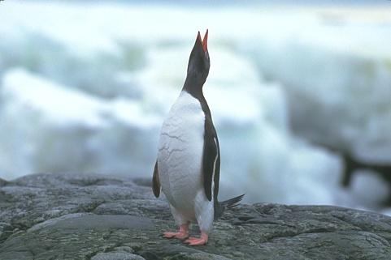

(original image)

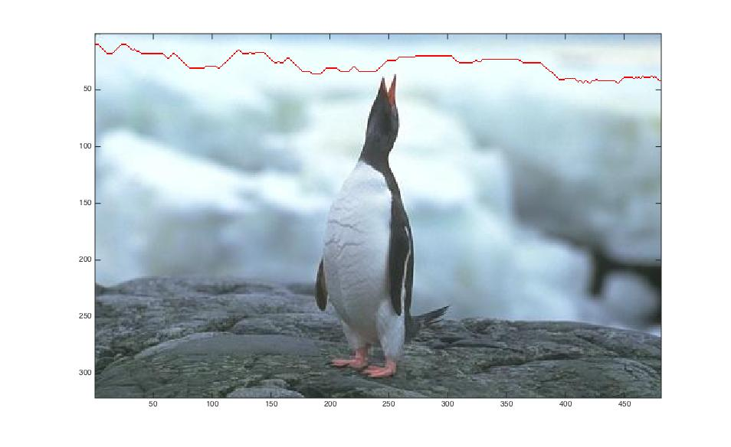

(image with one horizontal seam carving)

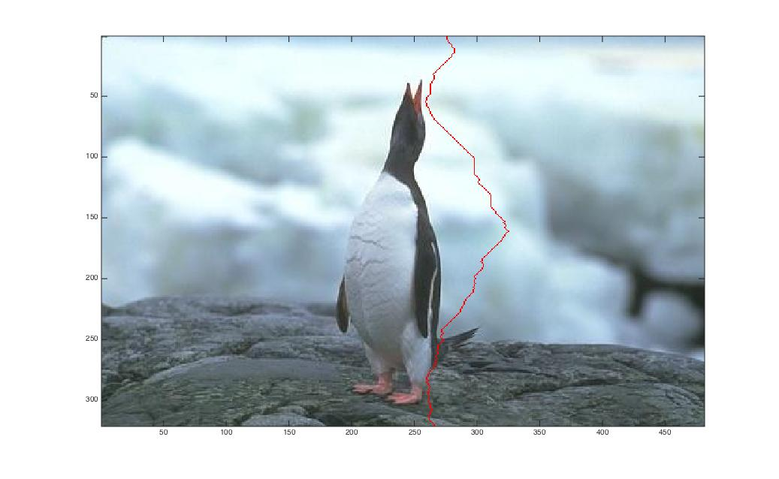

(image with one vertical seam carving)

Part 2. Image Mosaic (with geometric blur and blending affect)

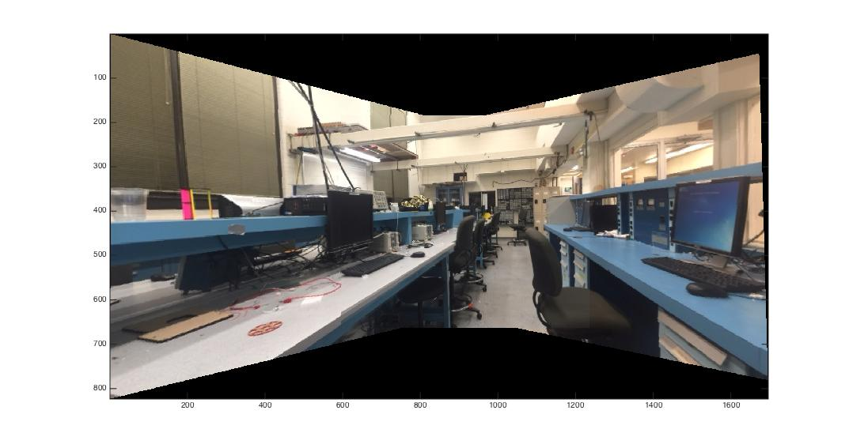

(Final result of images mosaic)

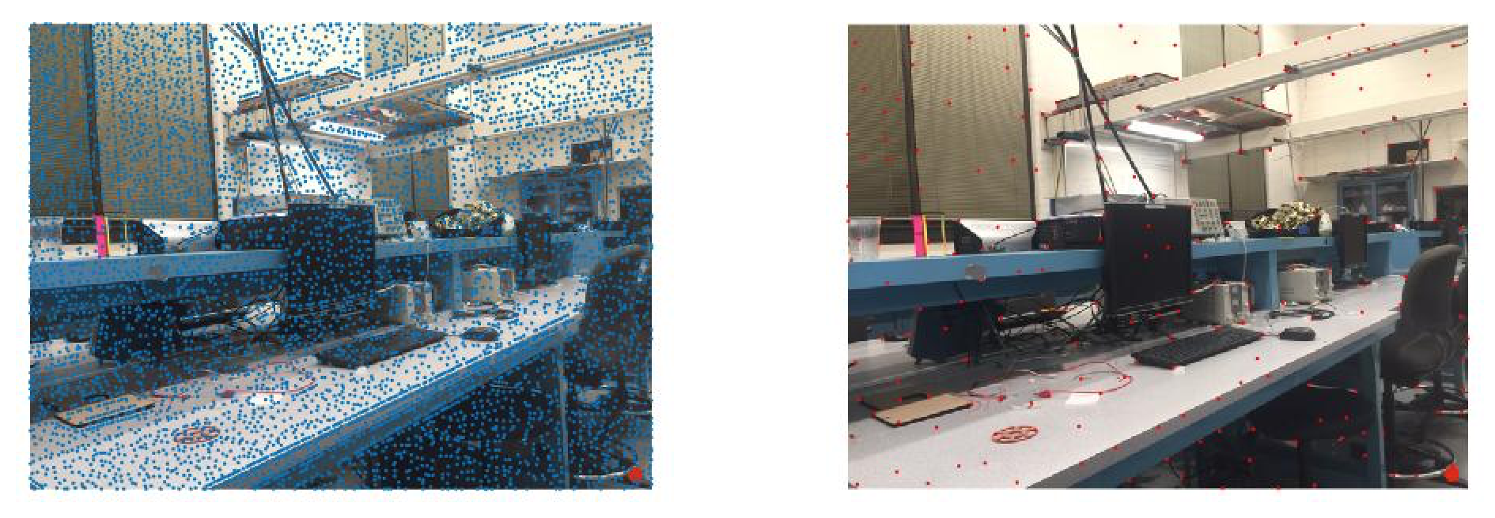

(Feature NMS for image 1: Blue dots are the corner detection result, red dots are the result from non-max suppression.)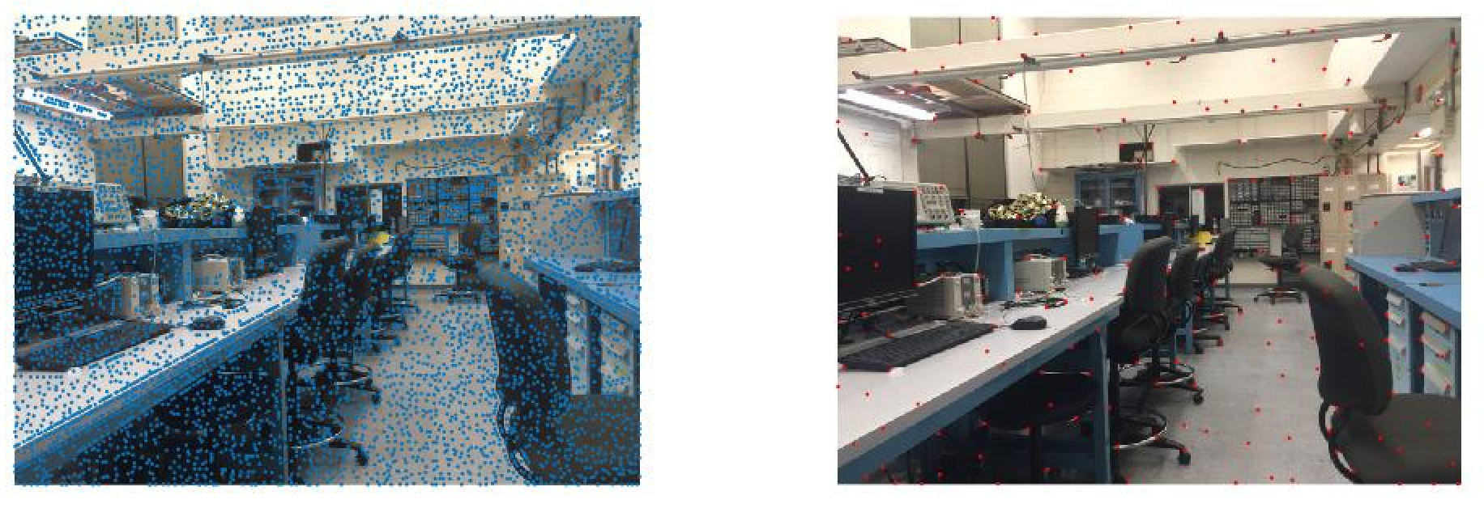

(Feature NMS for image 2: Blue dots are the corner detection result, red dots are the result from non-max suppression.)

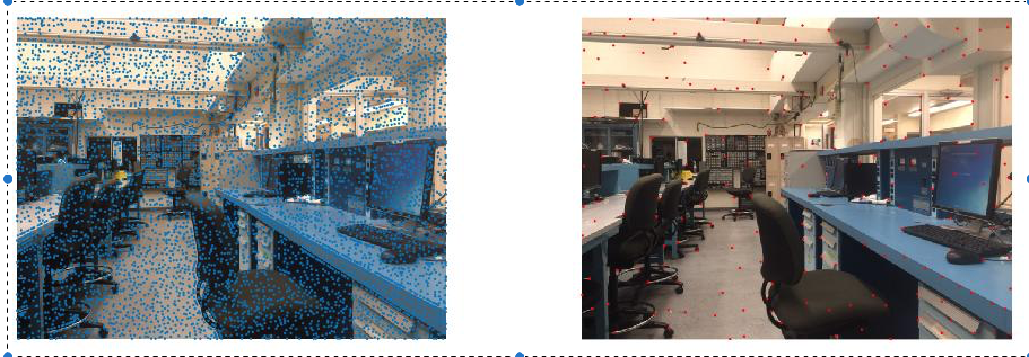

(Feature NMS for image 3: Blue dots are the corner detection result, red dots are the result from non-max suppression.)

3image 1ed features ae dbut onlt

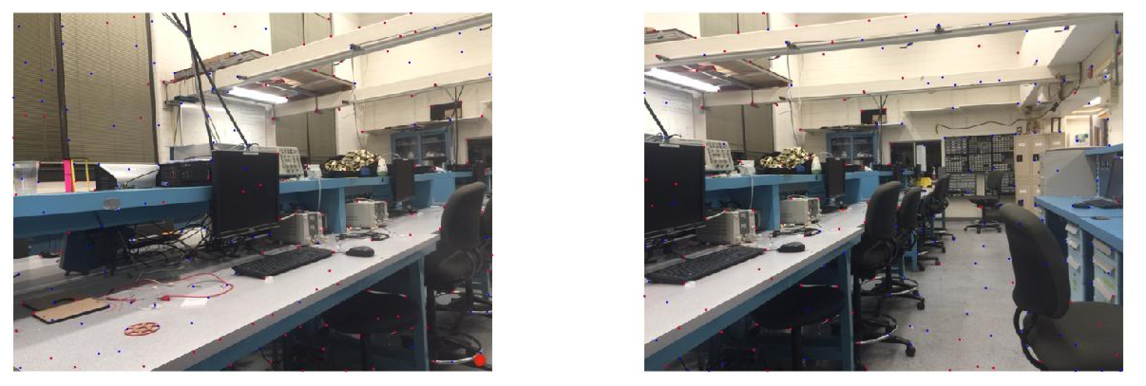

(Feature matching image 1 and image 2, red dots are the selected matched features)

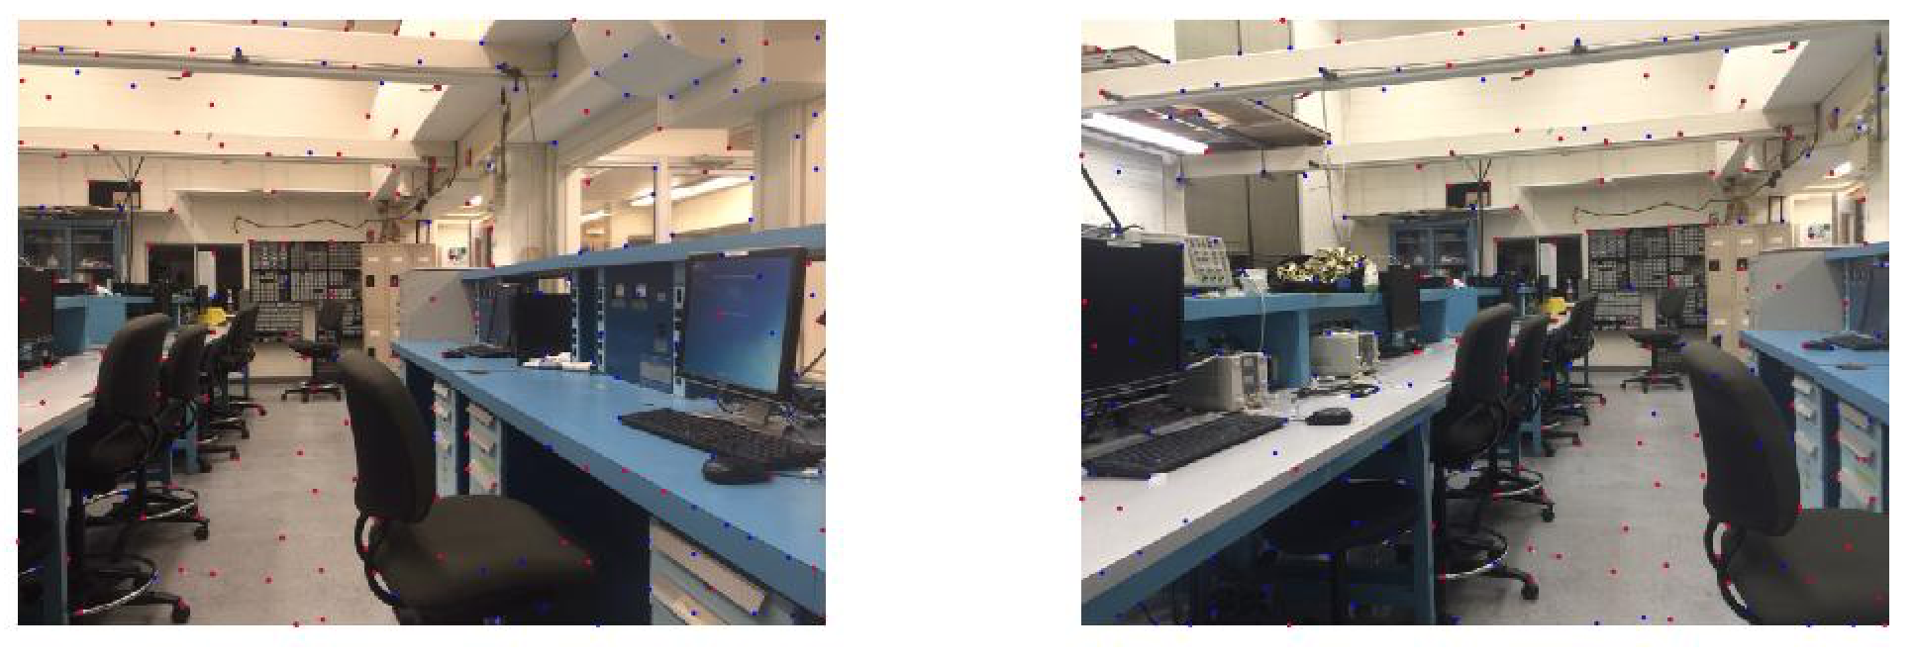

(Feature matching image 3 and image 2, red dots are the selected matched features)